**DAILY ONLINE ACTIVITIES SUMMARY**

|  |  |  |  |  |  |  |  |  |
| --- | --- | --- | --- | --- | --- | --- | --- | --- |
| **Date:** | **15-06-2020** | | | | | **Name:** | **Kanaka BS** | |
| **Sem & Sec** | **6th & A** | | | | | **USN:** | **4al17cs039** | |
| **Online Test Summary** | | | | | | | | |
| **Subject** | | **Python (workshop quiz)** | | | | | | |
| **Max. Marks** | | **20** | | **Score** | | | **19** | |
| **Certification Course Summary** | | | | | | | | |
| **Course** | 9:00 am to 11:00 am - Programming in C  11:00 am to 1:00pm - Applications of python in DA and ML | | | | | | | |
| **Certificate Provider** | | | **Vivek Sharma**  **Dr. Mohideen**  **Badusha** | | **Duration** | | | **4hours** |
| **Coding Challenges** | | | | | | | | |
| **Problem Statement:** 2 Programs | | | | | | | | |
| **Status: Solved** | | | | | | | | |
| **Uploaded the report in Github** | | | | | **yes** | | | |
| **If yes Repository name** | | | | | <https://github.com/kanakabs/Daily-Status/tree/master/15-06-20> | | | |
| **Uploaded the report in slack** | | | | | **yes** | | | |

Python Quiz:

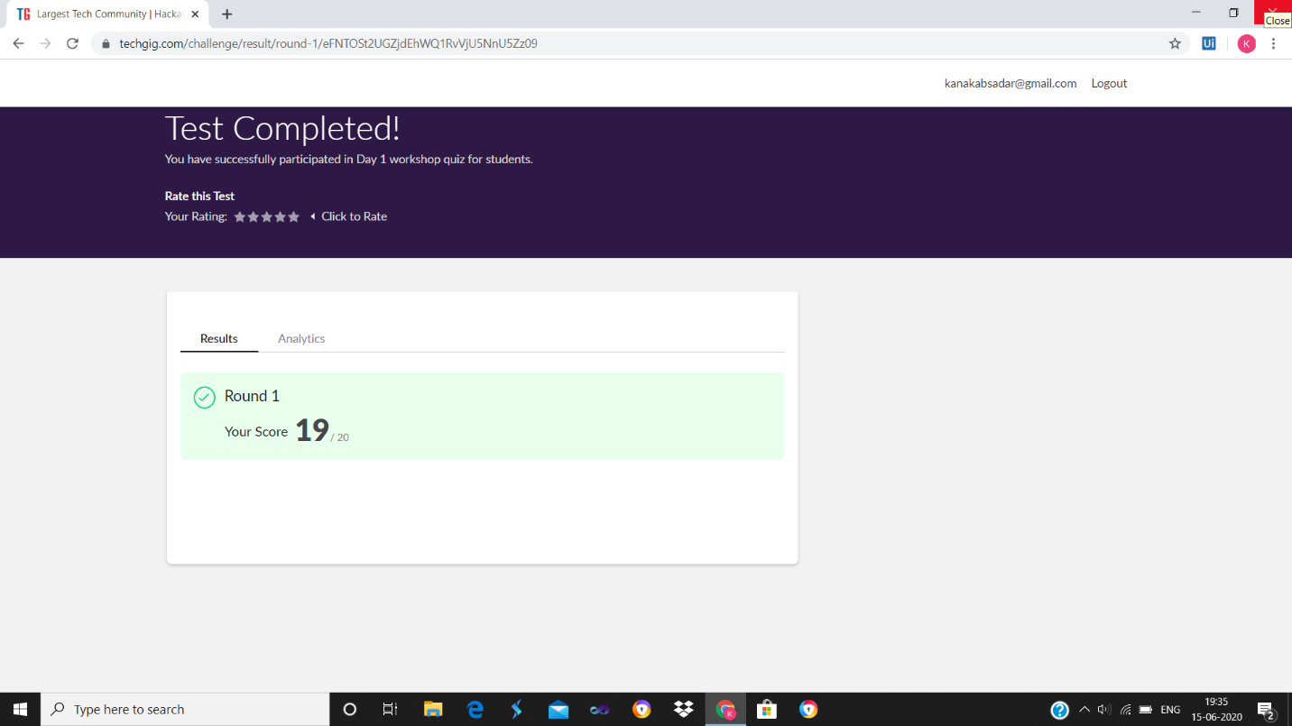

**SNAPSHOTS**

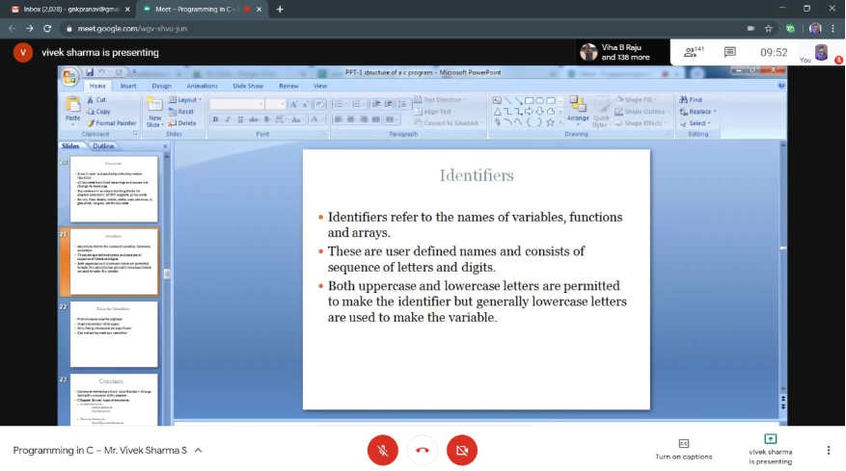

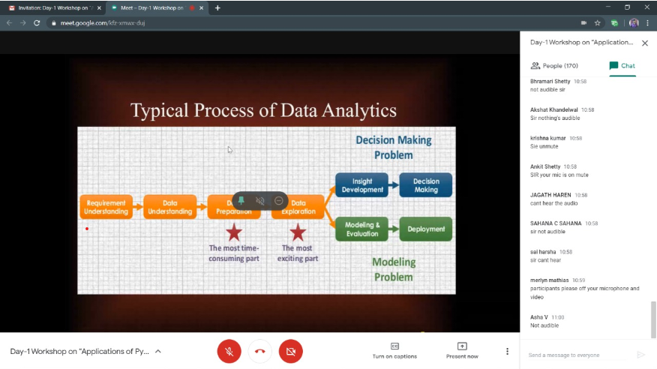

ONLINE CODING

<https://github.com/kanakabs/Daily-Status/tree/master/15-06-20/online%20coding>

